My final project consists of a concept that I have developed, called barberly. Barberly is an on-demand service where users can request a barber at the push of a button. A user will only be able to view barbers within a certain perimeter. Once a barber is selected, the goal is to have the barber show up to the user’s location within one hour and provide the user with the grooming service requested. The services will be prepaid, and barberly will not release the payment to the barber until the completion of the service is confirmed.

For the purpose of this project, I’ve already made some changes to my designs. I’d like to focus on certain aspects of my full app. I will mostly focus on developing the user interface and create a portion of the barber interface.

**CUSTOMER INTERFACE**

barber.ly

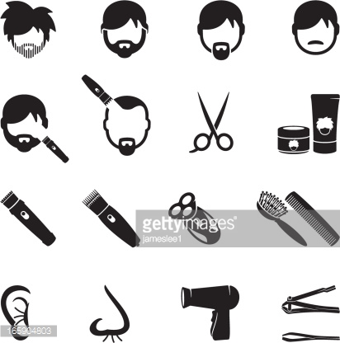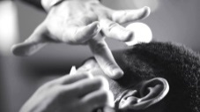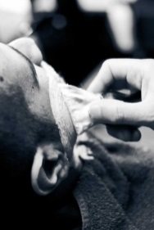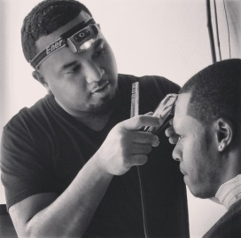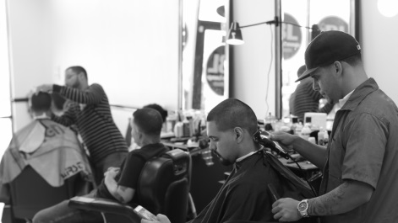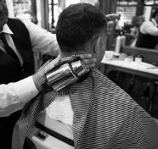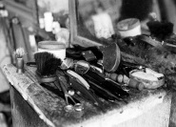

**SIGN IN**

**REGISTER**

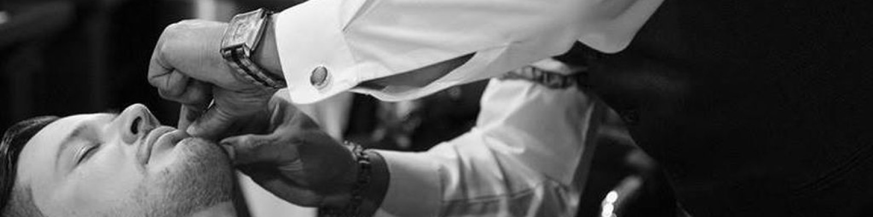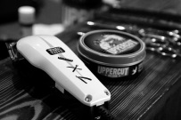

Email

Password

First Name

Last Name

Phone Number

Edit Photo

**DONE**

**CANCEL**

**USER REGISTRATION**



**Add Photo**



**CANCEL**

**REGISTER**

**I AM A USER**

**I AM A BARBER**



**BACK**

**BARBERS**

**John Smith**

**Johnny Tran**

**Matthew Lane**

**Ken Thomas**

**James Daniels**

**Joey Parker**

**Roger King**

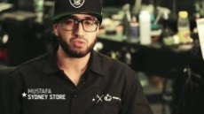

**2.0 miles**

;2

;2

;2

;2

;2

;2

;2

;2

;2

;2

;2

;2

;2

;2

;2

;2

;2

;2

;2

;2

;2

;2

;2

;2

;2

;2

;2

;2

;2

;2

;2

;2

;2

;2

;2

**3.4 miles**

**1.2 miles**

**0.75 miles**

**5.6 miles**

**0.35 miles**

**2.8 miles**



barber.ly

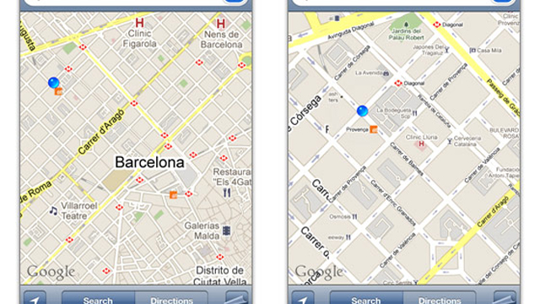

**Request a Barber**

**my location**



4 Star Rating

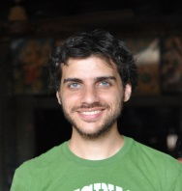

**BACK**

**PROFILE**



**Joey**

**Parker**

**Specialty: Fades**

**Portfolio**

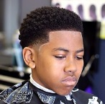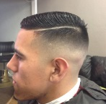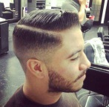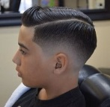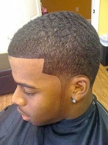

**Select Barber**

;2

;2

;2

;2

;2



**HOME**

**CONFIRMATION**

**Appointment Time 7:00 pm**

**Thank you for using barber.ly. We hope that you will enjoy your experience. You will receive an email confirmation shortly.**

**Barber Joey Parker**

**BARBER INTERFACE**

barber.ly



**SIGN IN**

**REGISTER**



**CANCEL**

**REGISTER**

**I AM A USER**

**I AM A BARBER**



Email

Password

First Name

Last Name

Phone Number

Edit Photo

**DONE**

**CANCEL**

**BARBER REGISTRATION**



**Add Photo**



**BACK**

**REQUEST**



**Customer:**

**James Daniels**

**4511 H St NW**

**Washington, DC 20002**



**Accept Request**



**GO LIVE**

**READY TO ACCEPT REQUESTS?**

**Yes**

**By selecting yes, you are now going live and making yourself available to receive work requests from clients.**

**Start Working!**